

**CSE 460**

**VLSI DESIGN**

**Lab Assignment 5**

**Name: Dipak Debnath Arka**

**ID: 20301066**

**Sec: 09**

***Problem 1:*** Implement the following Boolean logic expression using CMOS (PMOS+NMOS). Don't use any logic gate directly in your schematic, you have to implement the logic using MOSFETs. F = A(B+C)

**2. Truth Table**

|  |  |  |  |
| --- | --- | --- | --- |
| **a** | **b** | **c** | **f** |
| **0** | **0** | **0** | **0** |
| **0** | **0** | **1** | **0** |
| **0** | **1** | **0** | **0** |
| **0** | **1** | **1** | **0** |
| **1** | **0** | **0** | **0** |
| **1** | **0** | **1** | **1** |
| **1** | **1** | **0** | **1** |
| **1** | **1** | **1** | **1** |

**3. Screenshots of schematics**

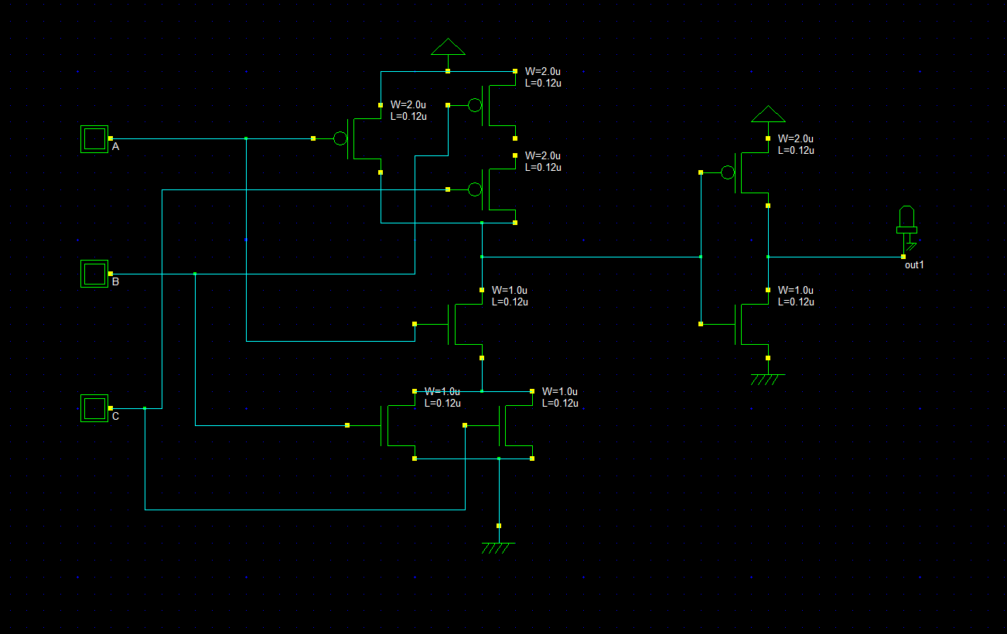

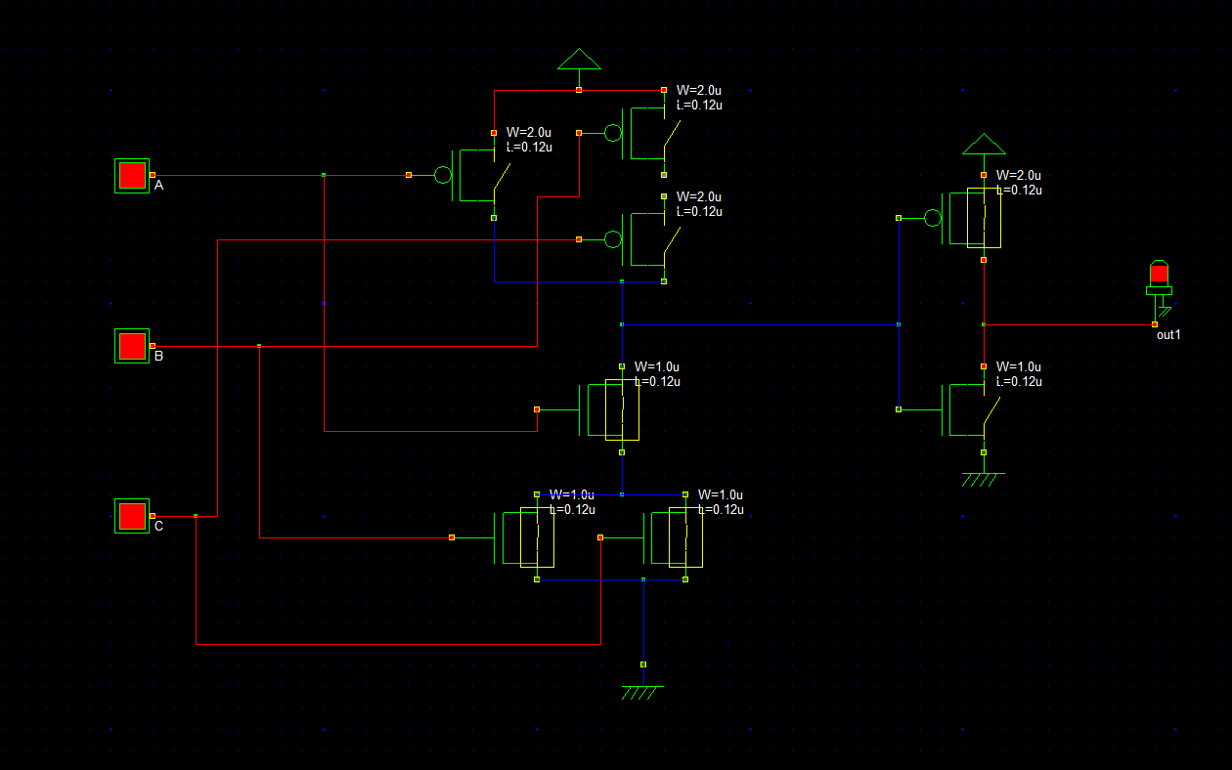

**4. Timing Diagram**

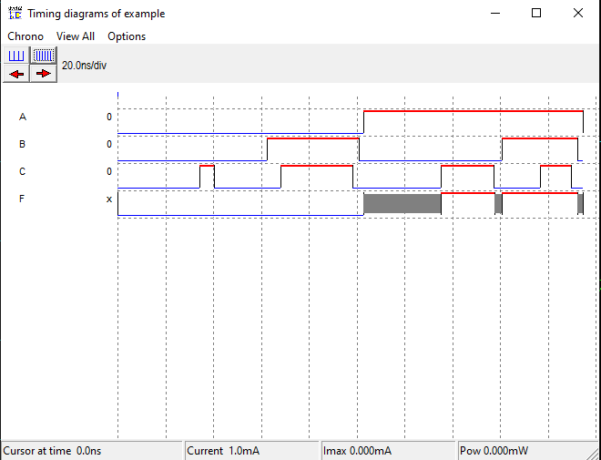

**Explain:**

In this timing diagram, it clearly manifests desired output. From the truth table we can see in this logic function the output is 1 when the input combination A,B,C is 101 , 110, 111 . In the timing diagram we also see the output is 1 when input is 101,110,111 . It matches with the truth table.